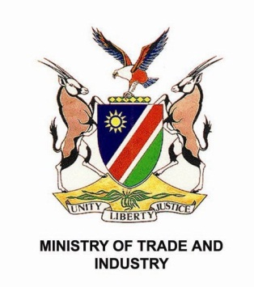

**TERMS AND CONDITIONS**

1.     Price of offer to include delivery, installment and commissioning at Ondangwa Tannery, Portion 1 Main Road Ondangwa, Namibia

2.     **Expected delivery time: End of January 2014 (if possible)**

3.     Training of 3 operators to be included in offer

4.     Offer to include a separately quoted maintenance plan for 3 years

5.     Payment Terms:  Letter of Credit, 80% draw down machine delivered and unpacked on site and 20% after commissioning and training and normal operation completed

6.     NDC expects Operating, Maintenance and Spares Manual in English, 2 hard copies and one electronic copy on DVD or Memory Stick

7.     Set of special (repair and maintenance) tools for the machines and equipment must be provided

8.     Details of service requirements (electric, water, compressed air connections) must be provided

9.     Detailed drawing of the foundation and movement of machinery/equipment on rail system (where applicable) must be provided

10.  List of reserve spares must be indicated

11.  Guarantee years must be indicated